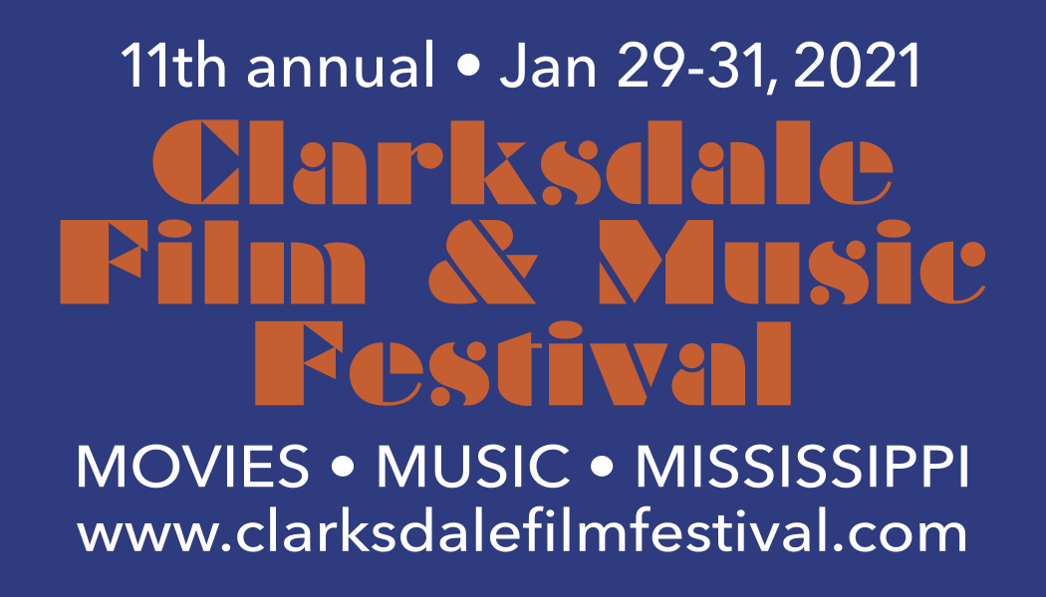

11th annual Clarksdale Film & Music Festival is brought to you by same fine folks who organize Juke Joint Festival – your nonprofit Clarksdale Downtown Development Assoc.
NOTE: This year’s festival will be a unique hybrid of pop-up indoor theaters, a pop-up drive-in theater and other socially-distanced film and music venues.

2021 FESTIVAL DATES:
Friday-Sunday, January 29-31

EVENT CONTACT INFORMATION:
www.clarksdalefilmfestival.com • roger@cathead.biz • pba@cableone.net

OFFICIAL FILM FESTIVAL ENTRY FORM:

Each film requires its own entry form, please. Questions? Email roger@cathead.biz

FILM INFORMATION

Title ____________________________________________________________________

Total Run Time ___________________________________________________________

SPECIAL CONSIDERATION

Premiere (world/state/city)? __________________________________________________

Clarksdale or Mississippi Connection? __________________________________________

Blues or Roots Music Related? ________________________________________________

Director Name(s) __________________________________________________________

_________________________________________________________________________

Producer Name(s) _________________________________________________________

_________________________________________________________________________

Brief Synopsis

__________________________________________________________________________

__________________________________________________________________________

__________________________________________________________________________

__________________________________________________________________________

__________________________________________________________________________

CONTACT INFORMATION

Film Web Site ______________________________________________________________

Contact Person _____________________________________________________________

Company Name _____________________________________________________________

Address ___________________________________________________________________

City ________________________ State ______________ Zip _____________________

Phone # ____________________________ Alt Phone # __________________________

E-mail Address ________________________ (required)

TECHNICAL INFORMATION

Screening Format (please note if PAL format instead of NTSC or if there are region issues)

Blu-ray? Yes __ No _ DVD? Yes __ No __

SUBMISSION DETAILS:

• Mail two Blu-rays or DVDs of your work (each film on separate disc unless multiple film shorts being entered as one project) to: Clarksdale Film & Music Festival, c/o Roger Stolle, 252 Delta Avenue, Clarksdale, MS 38614.

• Label each disc with the name of work, name of submitter and length of work.

• Include completed/signed copy of this entry/application form.

• Include appropriate film festival entry fee; check made out to “Clarksdale Film Festival”: Regular entry $10. Late entry $20.

• Submissions start October 15, 2020. Regular deadline for normal film entries is December 15, 2020.

• Extended deadline for late entries is December 31, 2020.

• Accepted film entries will be announced by early January 2020. (Submitters may check on the status of their film at any time via the email addresses above.)

By submitting this form the submitter states that he or she:

• Is authorized to submit the film as the Maker or an Agent of the Maker. And is responsible for all rights/licensing to music, images, etc. included in the submitted film.

• Has accepted the rules and regulations of the Clarksdale Film Festival and its organizing body.

• Agrees that the TWO submitted discs will not be returned without a self-addressed stamped envelope included by submitter.

• Allows the Clarksdale Film Festival and its organizers the right to promote, through all media types and outlets, the film submitted and allows the film to be screened at all Clarksdale Film Festival and related events.

• Understands that the details of this event can change at any time and without notice. Furthermore, entry into this film festival does not constitute any guarantee of screening/inclusion.

I have read and filled out this form (as required) and I understand the Clarksdale Film Festival is not responsible for damages or losses resulting from the festival review, exhibition or any other possible or unforeseen circumstance.

______________________________________________________ _________________
Submitter's Signature and Printed Name Date

THANKS, Y’ALL!

